BRACT’s
Vishwakarma Institute of Technology, Pune
Practical Implementation Sheet
Department: CSE-AI Semester: 5 Academic Year: 2026-27
Division: E Batch: 2 Practical No: 2
Roll no: 37 PRN No: 12412175 Name of Student: Rugved Raut
Subject Name : Deep Learning

Problem Statement
Design and implement a Multilayer Perceptron (MLP) for classification of the Wine dataset and evaluate its performance using accuracy and a confusion matrix.

Algorithm
- Start the program.
- Import the required libraries: NumPy, Matplotlib, Seaborn, TensorFlow, Keras, and Scikit-learn.
- Load the Wine dataset using load_wine().
- Separate the dataset into input features (X) and target labels (y).
- Display the shape of the dataset, feature names, and target class names.
- Split the dataset into training and testing sets using train_test_split().
- Standardize the training and testing datasets using StandardScaler.
- Create a Multilayer Perceptron (MLP) model with an input layer, two hidden layers using ReLU activation, and an output layer using Softmax activation.
- Compile the model using the Adam optimizer and Sparse Categorical Crossentropy loss function.
- Train the model using the training dataset for 50 epochs.
- Plot the training and validation accuracy graph.
- Plot the training and validation loss graph.
- Evaluate the trained model using the testing dataset.
- Predict the class labels for the testing dataset.
- Calculate the classification accuracy.
- Generate and display the confusion matrix.
- Display the classification report.
- Stop the program.

Code :
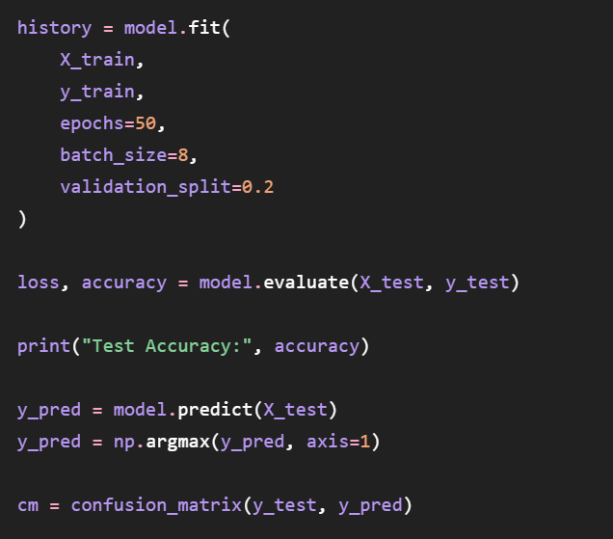

Output
- 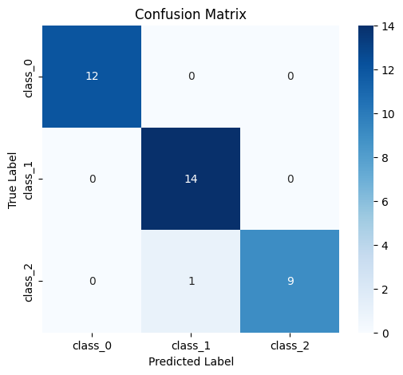

Final Accuracy: 97.22%

